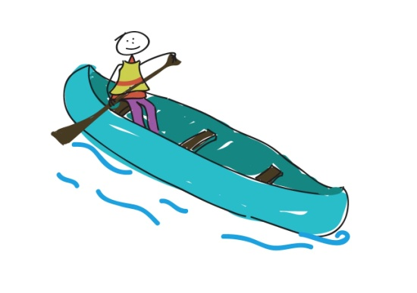**COTTAGE CHAT TRAINING**

You are leading cottage chat tonight and you have had a stressful day and your campers have been irrating you all day.

Take a moment and think about these children, think about what great children they are, think about what you want for them this week. Think about what you want them to dream about that night and now think of a question that will make them want to dream about that tonight.

**Cottage Chat – Kids**

**Start of session:**

* If you could have any superpower, what would it be and why?
* If you could fill a swimming pool with something, what would it be?
* If you could combine two animals what would it be?
* What are you most looking forward to about Barretstown this week?
* If you could go anywhere in the world where would you go?

**Middle of session:**

* Take a snapshot of the day.
* If you could open a door to anywhere?
* What are you most proud of?
* Say something that you saw in someone that you admire, or something you saw someone do that you thought was super duper awesome or amazing.
* If you had a time machine where would you go?
* If you had a role model growing up, who was it?
* Who is somebody that you respect?

**End of session:**

* What would you like to take home with you from Barretstown?
* When you get home, what is the first thing you will tell somebody about Barretstown and who will it be?
* What are you looking forward to most about going home?

**Cottage Chat – Teens**

**Start of the session:**

* If where going to a dinner party with 2 other people, who would you invite and why?
* If you could fill a swimming pool with something, what would it be?
* What would you do with ten million euro/pounds?

**Middle of session:**

* What are most proud of?
* Say something cool you seen somebody do.
* If you could change one thing in the world, what would it be?
* Say a wish for yourself, and a wish for someone else.
* Get them to choose a question.

**End of session:**

* Spider web – Bracelets and wishes.
* Highlight of your time in Barretstown?
* Is there anything you learned about yourself at camp?
* Warm and fuzzies – write some messages.

**Other ideas:**

**First night questions:**

* Favourite food to eat?
* Favourite thing to do outdoors?
* What is your idea of the most perfect day?
* If you could have one super power what would it be?
* If you could meet anyone famous, who would it be?
* What kind of music do you like?
* What do you like to do when you’re not in school?
* If you could go anywhere in the world, where would you go?
* If you could fill a swimming pool with any one thing, what would it be?
* If you could be any animal, what would you be?
* If you could create a flavour of ice cream, what flavour would it be?

**Day two:**

* What was your favourite thing from today? What are you most excited about for tomorrow?
* Pick two roses and a thorn (2 good things that happened in the day, and one that you wish you could improve)/two stars and a wish (two highlights from the day and one wish for tomorrow).
* Favourite or funniest part of the day?
* If you were to thank somebody today who would it be and for what?
* What are your goals or wishes for the rest of the session at camp?

**Day three to nine:**

* If you were stranded on a deserted island what 3 things would you want to have with you?
* What are three important things you would take with you if you were travelling on a long trip for a year?
* If you could have dinner with 2 famous people, who would they be?
* If you won two million Euros, what would you do?
* What is something about yourself that you are most proud of?
* If you could change one thing about the world, what would you change?
* If you could have three wishes, what would they be?
* What has been your greatest accomplishment/what are you most proud of?
* What is something that makes you special?
* Who is someone that you admire? Who is someone that admires you?
* What does it mean to be a good friend?
* If you could take one memory from today/this week so far, keep it in your pocket and take it out whenever you needed it, what would it be?
* What has been your favourite part of camp so far? What are you most looking forward to for the rest of the week?
* If you could add anything to camp, what would it be?
* What is the nicest/coolest thing you saw someone do today?

**Bringing campers full-circle…preparing them for home:**

* When you tell your friends back home about camp, what will you tell them?
* What makes camp different from the outside world? How can we bring camp to the outside world?
* What is your favourite memory from this week at camp?
* What have you learned about yourself this week at camp?
* If you could pick three words to describe this week at camp, what would they be?
* What are you most excited about in terms of going back home/what is the first thing you will do when you get home?
* Draw a picture of yourself here at camp and put your favourite memories on it.
* Positivity Bombardment sheets: Give each child a sheet of paper to put their name on and pass it around to each camper to write a memory, or something nice about that camper…for each one of the campers to take home.
* If you could bottle up something from camp and bring it home with you to share, what would it be?