**HOW CAN I BE HELPFUL IN ACTIVITIES AS A CARA??**

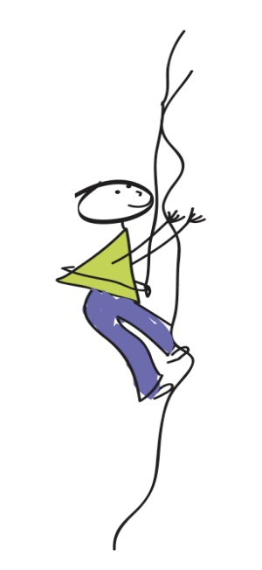**New Heights/High Ropes**

* Please ensure that campers or caras DO NOT walk on to the wood chippings around the ropes course.
* Please assist campers with their harnesses and helmets.
* Please show interest in how the campers are feeling, help, understand and encourage them.
* If a camper wishes not to climb that is perfectly fine, but please would you be able to help entertain them with games etc.
* Please encourage campers who may be standing in a long line for a certain element   
  to try one with a shorter line, or if someone has already climb one element to let someone else step in front.

**Terminology for New Heights**

**Carabiner:** A metal device which is used to connect various elements of rope and safety equipment.

**Chest & Waist Harnesses**: Safety equipment which is used to secure the camper to the climbing rope

**Staples:** Metal pieces attached to the side of the pole which the camper can step on to climb up the course.

**Wooden blocks:** Wooden pieces attached to pole which the camper can step up to climb up the course.

**Trapeze bar:** An element where the camper has the option to jump for a metal bar which is suspended in the air a short distance from the top of the pole.

**Canoeing**

* Please help keep kids focused on safety talk.
* Please help hand out buoyancy aids and helmets out to campers after the safety talk.
* Black helmets are the biggest, navy are slightly smaller but still big and the red are the smallest they can also be adjusted to fit. Helmets should fit head comfortably and sit just above the eye brows.
* Try use red buoyancy aids first, for smaller kids (under 8/9)... there are smaller buoyancy aids available to the left of the back wall please ask first. Buoyancy aids should be tight enough not to rise up.
* A Cara or an AL must be sitting at the end of the boat to help keep boats steady while entering the water. Please wait till an AL is in the water before sending the campers in.
* If Cara's are getting into the boat with the campers please sit to the back of the boat, as this can give you more control over the steering of the boat etc.
  + **Entering the canoe:**
    - Before entering and exiting the boat make sure someone is always sitting on the end of the boat to keep it steady
    - Lean over boat and put your paddle on the boat rails, one foot at a time into the centre of the boat “staying low in the boat”
    - Slide Paddle along rails down to your seat when you reach your seat turn around and sit down
* **How to steer the boat:**
* To paddle forward put paddle in the water beside your toes, and push all the water behind you
* To paddle backwards put paddle in the water behind you and push all the water in front of you
* To steer the canoe straight have one person paddle on the right side of the canoe and the other paddle on the left side of the canoe
* Saddle - leather seat fastened on the back of the horse

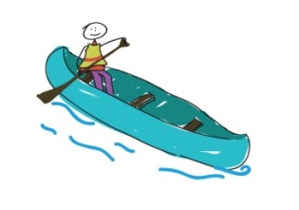

**Horses**

* Be proactive and letting us know whether they feel comfortable or not leading a horse or have any allergies around them.
* Make sure everyone is wearing long trousers and sleeves.
* **Please do not take your hour off during horses.**
* En route to course engage campers with conversations, games or chants.
* **O**nce at the course we can use any help in managing group - keeping quite around the animals, fixing safety gear (helmets and boots - only for campers unless otherwise instructed!)
* Help focusing on safety talk (role modelling).
* Keep calm around horses, even if they are acting up to make sure campers feel safe - ask for assistance if needed, Jenny is always with the group

**Terminology for Horses**

**Bridle** - headgear used to control the horse, consists of reins and buckled straps.  
**Reins** - long narrow strap attached to horses bit which the rider holds to control horse.  
**Stirrups** - metal flattened loops attached to either side of saddle for rider's feet.

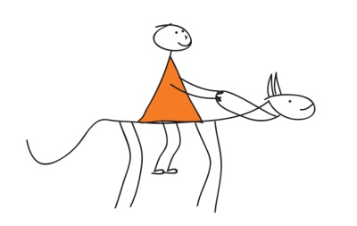**Indoor Arena** - covered area used for riding during wet conditions  
**Bit -** piece of metel that rests in the horses mouth  
**Girth** - strap attached to either side of the saddle and straps around the horses stomach just behind front legs  
**Riding boots** - appropriate footwear for horseriding  
**Riding hat** - protective headwear for riding  
**Numnah** - fabric that sits beneath the saddle  
**Martingale** - strap attached to one end of the reins  
**Hind legs** - horses back legs

**Fishing**

* Cara's carry a cup of sweet corn, campers are NOT allowed to put the corn on the hook.
* Yell “Fish” with the campers if they catch a fish then the AL can hear and come over to de-hook it.
* Help smaller campers with the casting of the rod, side cast always.
* Only 4 campers on the walkway to the boat, none on the bridge, 2 on the boat. make sure there is at least 2m between each camper.
* Float around to the different spots and see if the campers need a hand.
* [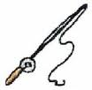](http://www.google.ie/imgres?imgurl=http://www.trout-fishing-basics.com/images/Cartoon-fishing-rod_qjgenth.jpg&imgrefurl=http://www.trout-fishing-basics.com/fishing-rods.html&usg=__cEegtdqZnrBdIEo0---R6wUInI4=&h=196&w=200&sz=8&hl=en&start=17&itbs=1&tbnid=EInYm2zpBbugQM:&tbnh=102&tbnw=104&prev=/images?q=fishing+for+trout+cartoon&hl=en&gbv=2&tbs=isch:1)Please help keep kids focused on safety talk.

**Fishing**

**Reel-** holds the fishing line/string

**Loop-** holes the fishing line is fed through

**Hook-** shoney metal thing on end of line, very sharp

**Corn**,-used as bait to catch fish, get bites

**Casting Technique:**

Hold line against fishing rod,

Open reel,

Pull rod back sideways and yell "Casting"

Follow through with cast and let go of fishing line towards the front of the body,

Close reel and enjoy!

**Archery**

* Being proactive and making sure everyone is wearing long sleeves before coming down to the course.
* We would appreciate initiative in managing lines/group when waiting for activity or during safety demonstration - important that everybody can see and hear properly.
* Assistance in putting on safety gear (armguards) and also at shooting stands if they feel comfortable in instructing and collecting arrows (no kids are allowed to do this) - this one might be a great opportunity for returning volunteers to try themselves in a new area.
* It would be great help if you helped keeping kids behind the blue rope and entertained while they are not shooting (backpocket games, tricks, cheering, etc.)
* Enthusiastic attitude about the actual activity, mirroring the AL - this helps getting Campers engaged as well.

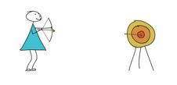

**Terminology for Archery**

**Bow**- device used for firing arrows

**Arrow**- fired by bow towards target

**Armguard**- arm protection used on arm holding bow

**Shooting mat**- mat stood on while shooting

**Shooting Line**-everyone shoots along the one line

**Arts and Crafts**

* Show interest in campers. Engage them and help them with their projects.
* Please don’t make your own projects in A&C.
* Help with the cleaning up process.
* Put things away, wash paintbrushes, help wash hands etc.
* Put names on all camper’s art work and put into the correct cottage box.

**SAFETY INSTRUCTIONS FOR ACTIVITIES**

**(HELPFUL FOR INTERPRETERS)**

**[](http://www.google.ie/imgres?imgurl=http://www.trout-fishing-basics.com/images/Cartoon-fishing-rod_qjgenth.jpg&imgrefurl=http://www.trout-fishing-basics.com/fishing-rods.html&usg=__cEegtdqZnrBdIEo0---R6wUInI4=&h=196&w=200&sz=8&hl=en&start=17&itbs=1&tbnid=EInYm2zpBbugQM:&tbnh=102&tbnw=104&prev=/images?q=fishing+for+trout+cartoon&hl=en&gbv=2&tbs=isch:1)Fishing**

* Only Cara’s can put bait on hooks
* Do not eat the corn
* You can only cast to the side-not over your head
* Shout FISH if you caught a fish
* Only adults can unhook fish
* Only two people can fish off the boat and in the huts
* You cannot stand on the side of the Boat
* Shout casting when casting
* Everyone must wash their hands after the activity

**Archery**

* Stay behind the blue rope until you care called
* Must be wearing longs sleeves and an arm guard while shooting
* You must be wear closed toe shoes and long sleeves
* Bow should always be aimed at the target
* Everyone must wait until you get the OK from the activity leader to shoot
* Only put arrow in bow when standing on the shooting line
* Only adults are allowed to collect the arrows

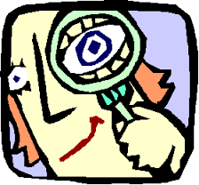**Discovery**

* Stay within the designated areas
* Do not eat or drink anything in discovery
* Watch out for uneven surfaces

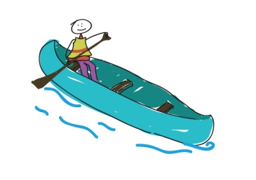

**Canoeing**

* Always stay sitting in the middle of your seat
* Do not slash or bump other while canoeing
* Never stand up in the canoe
* Everyone must wear a life jacket and helmet
* Everyone must wash their hands after the activity

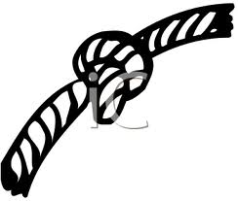**High Ropes/ Climbing Wall**

* Listen to all instructions given by the activity leaders
* Stay off wood chippings/blue mats unless instructed.
* Please wear a helmet on wood chippings/blue mats.
* Harness should be above the hips.
* Please queue at the element you would like to climb

**Low Ropes**

* Listen to all instructions given by the activity leaders
* No running
* No climbing the trees
* Stay together as a group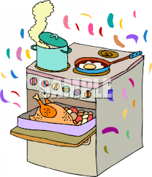

**Baking**

* Keep away from the oven
* Keep area clean and tidy
* Wash your hands before and after the activity
* Only Caras are allowed to put things in and out of ovens
* Campers are not allowed to eat the raw batter (especially with uncooked eggs)



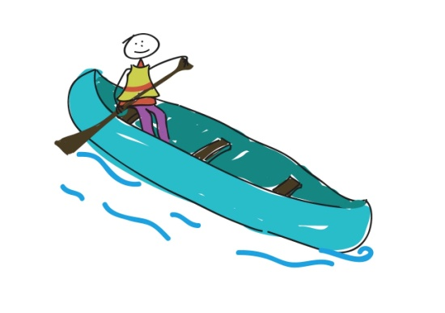[](http://www.google.ie/imgres?imgurl=http://www.bcsc.k12.in.us/csalc/lib/csalc/CameraClipArt.jpg&imgrefurl=http://www.bcsc.k12.in.us/csalc/&usg=__BkVJ90f1iJBl8W-9263UdqSUnj4=&h=297&w=350&sz=36&hl=en&start=3&itbs=1&tbnid=ME9A8qiJwvUbwM:&tbnh=102&tbnw=120&prev=/images?q=camera+clip+art&hl=en&gbv=2&tbs=isch:1)

**Photo**

* When room is dark it is important that energy remains calm and movement remains slow and careful as it is a small room and difficult to see
* When using chemicals it is important to use tweezers/clamps to move photos from one development station to another
* If chemicals get on hands it is OK, but important to not rub face or touch eyes
* Hand washing after activity is mandatory

**Arts and Crafts**

* Be mindful of hot taps
* No running
* No climbing
* Benches are for sitting on
* Listen carefully to instructions from the Activity Leaders and Caras

**Horses**

* Stay calm and do not make too much noise around the animals because you don’t want to give them a fright
* Don’t walk behind the horses
* Don’t feed the animals
* Everyone must be wearing a helmet and boots while riding
* Everyone must be wearing long trousers while riding



**[](http://www.google.ie/imgres?imgurl=http://comps.fotosearch.com/comp/IMZ/IMZ109/creative-writing_~cfr0021.jpg&imgrefurl=http://www.fotosearch.com/IMZ109/cfr0021/&usg=__YxbYqYcuXLFQ3W_-WQnopOsKIXE=&h=214&w=300&sz=23&hl=en&start=36&itbs=1&tbnid=ZCoSr2TaqsO5nM:&tbnh=83&tbnw=116&prev=/images?q=creative+writing&start=20&hl=en&sa=N&gbv=2&ndsp=20&tbs=isch:1)Imagination Station**

* No running
* Ask a Cara if you need anything extra
* Respect and support each other

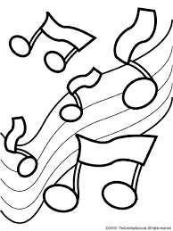**Music**

* No running
* Respect and support each other
* If you would like to play a different instrument please as a Cara to get it for you because some of the instruments are heavy
* Please do not play your instrument while other people are talking

**Drama**

* No running
* Ask a Cara if you need a different costume
* Respect and support each other
* Please do not go behind the curtain

